<Customer Name>
<Project Name>
Application Design
<Version No.>



 | Prepared By | Reviewed by | Approved By
Name
Role |  | Project Leader | Project Manager
Signature
Date

Table of Contents
1.0 Introduction 3
1.1 Purpose of this document 3
1.2 Scope 3
1.3 Intended Audience 3
1.4 Definition & Acronyms 3
1.5 References 3
2.0 Conventions and Standards Followed 4
3.0 Assumptions, Dependencies and Risks 5
4.0 Use Case Realization 6
4.1 Flow of Events – Design 6
4.2 Derived Requirements 7
5.0 Package & Sub-system Design 8
5.1 Package Design 8
5.1.1 Packages 1…N 8
5.2 Sub-system Design 9
6.0 Generic Components Design 10
7.0 Object Model 11
7.1 System Object Model 11
7.2 Object Descriptions 11
7.2.1 Object <Name> 11
8.0 Database Design 12
8.1 Data Model 12
8.1.1 Identification of Tables 12
8.1.2 Table Details 12
8.1.3 Referential Integrity Constraints 12
8.1.4 Computations/processing in Database 12
8.1.5 Access Control Details 12
8.2 Storage Characteristics 13
8.3 Database Performance Improvement Measures 13
9.0 References 13
10.0 Change Log 14

Introduction

Purpose of this document
<The detailed design contains the design of every module / sub-system. This covers the following:
- Design of common / generic components
- Module / Sub-system design
- Unit / Class / Program Specifications
From a content consideration, the above three have been combined in this document. However depending on the scale of design or projects, from manageability and configurability point of view, the above three may be split and maintained>

Scope
<This sub-section shall state the scope of this detailed design document (Module name, functionality addressed etc.)>

Intended Audience
<The intended audience for this document is
- Developers, testers, other associates in the project
- Client
- Delivery Assurance Group, Process Engineering group >

Definition & Acronyms

References

Conventions and Standards Followed
<Please provide a list of all conventions and standards that will be followed in the design of the application>

Assumptions, Dependencies and Risks
<This sub-section shall list all the assumptions and dependencies taken into account while preparing the Detailed Design document. Such assumptions are not outstanding issues, as they ought to be clarified with the customer. Rather they are valid assumptions on which the design is based>

Use Case Realization
<The background or the reason that led to the initiation of the Business Context study to be mentioned here. >

Flow of Events – Design
<Description of how the use case is realized in terms of collaborating objects. Its main purpose is to summarize the diagrams connected to the use case and to explain how they are related through SEQUENCE DIAGRAMS and COLLABORATION DIAGRAMS >

Sequence Diagrams
<Interactions could be represented in the form of sequence diagrams. >
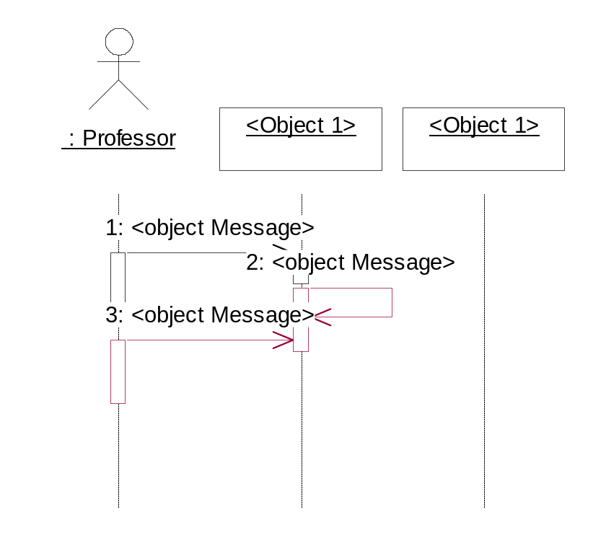

<<Insert sequence diagrams here. Please note that you could insert the diagrams here directly OR provide reference to the file, which contains this.
The actual insertion into the document can be deferred at the time of delivery of the document to the client.
But is necessary to specify the version number of every such document referenced here and every change in the referenced document should be tracked as part of the Change Log to the Design Document>>

Derived Requirements
<Description that collects all requirements, such as non-functional requirements, on the use-case realizations that are not considered in the design model, but that need to be taken care of during implementation>

Package & Sub-system Design
<The purpose of this section is to explain the design over view of package or the sub system. The Design Model can be split into smaller units to make it easier to understand. By grouping Design Model elements into packages and subsystems, then showing how those groupings relate to one another, it is easier to understand the overall structure of the model>

Package Design
<Packages are general-purpose hierarchical organizational units (units as in classes, relationships etc.). Such units are not contained in some other element. Elements such as attributes, operations, states, lifelines, and other messages are contained in other elements and do not appear as direct contents of packages.
A package may contain other packages. There is a root package that indirectly contains the entire model of a system. There are several ways to organize packages: - By view, BY functionality, or other relevant basis.
- If the packages are well chosen they can reflect the high-level architecture of the system.
- Identification of packages so that teams can work without interfering with each other.
- Delineating source code into logical partitions to enhance maintainability
- Implementing effective Configuration Management
- Access Control
Constructing libraries etc.>

Packages 1…N
<Packages may be depicted here>
Attribute Name | Brief Description of Attribute
Name | The name of the package.
Brief Description | A brief description of the role and purpose, or the "theme" of the package.
Classes | The classes directly contained in the package.
Relationships | The relationships directly contained in the package.
Use-Case Realizations | The use-case realizations directly contained in the package.
Diagrams | The diagrams directly contained in the package.
Design Packages | The packages directly contained in the package.
Import Dependencies | The import dependencies from the package to other packages.

Sub-system Design
<A subsystem is a physical unit of implementation with well-define interfaces that is intended to be used as replaceable part of the system. Each sub system embodies the implementation of certain classes. Well-defined subsystems do not depend directly on other sub systems but on interfaces that sub system support.
Note: If this already addressed as part of architecture, this may be skipped here and referenced here>
Property Name | Brief Description
Name | The name of the subsystem
Brief Description | The short description of the role and purpose, or the "theme" of the subsystem.
Interfaces | Associations to realized interfaces
Contents | Aggregation associations to contained model elements
Dependencies | Dependency associations to interfaces, packages, or subsystems on which the subsystem depends
Diagrams | Any diagrams local to the subsystem, such as class diagrams or statechart diagrams.

Generic Components Design
<Generic design may include the following:
- Framework classes
- Audit Trial Classes
- Authority Checks
- Alarms/Error/Notification Requirements
- Operational Sequence Check
- Device Check
- Electronic Signatures
- Process Control Parameters
- Authorization
- Record Access
- Record retention & recovery requiremen>

A component is a physical unit of implementation with well-defined interfaces that is intended to be used as replaceable part of the system. Each component embodies the implementation of certain classes. Well-defined components do not depend directly on other components but on interfaces that components support>

Object Model

System Object Model
<Provide the object model for the whole system. If the model is too big, partition the diagram using some reasonable criteria. For example, you may provide the client-side and the server-side object models as separate diagrams>

Object Descriptions
<In this section you would describe in detail each object, its attributes and its methods. You should logically group objects together. For example, you may use your architecture diagrams to group objects within a sub-system together. These may be directly referenced from Object Modeling tools if used in the project and maintained at the level given below >

Object <Name>
- Purpose:
- Constraints: None
- Persistent: No (created at system initialization from other available data)

Attribute Descriptions
- Attribute:
Type:
Description:
Constraints:
- Another attribute…

Method Descriptions
- Method:
Return Type: Boolean
Parameters:
Return value: success or failure
Pre-condition:
Post-condition:
2. Attributes read/used:
3. Methods called:
4.Processing logic:

Database Design

Data Model
<Map persistent design classes into the data model>

Identification of Tables
<While deriving tables from the object model, the different associations will need to be considered separately.
Example: A foreign –key reference for a 1:n relationship between customer and orders. In the case of aggregation association as in Order and Line items, ensuring a cascading delete will need to be factored. In many-to-many associations, an intersection entity will need to be considered (as in the case of many suppliers and many products.>

Table Details
<Provide a tabular format, which captures the following details. While deriving tables from the object model, the different associations will need to be considered separately.
Example: A foreign –key reference for a 1:n relationship between customer and orders. In the case of aggregation association as in Order and Line items, ensuring a cascading delete will need to be factored. In many-to-many associations, an intersection entity will need to be considered (as in the case of many suppliers and many products.>

Referential Integrity Constraints
<Specify all Primary Key, Foreign key, Triggers and other such constraints that enforce data integrity as well as referential integrity constraints>

Computations/processing in Database
<Identify stored procedures that will access these tables and the operations that this will perform. Remember that improving database performance usually means reducing I/O; as a result, if performing a computation on the DBMS server will reduce the amount of data passed over the network, the computation should probably be performed on the server. However they must be used judiciously.
In collaboration with class design, ascertain how database can be used to improve performance. The operation method will need to be updated to indicate that one or more stored procedures can be/should be used to implement the operation. >

Access Control Details
<Administrative details which are not specific to any program of the application, but connected to database/file system.
- Administration
- Security and access rights
- Record locking, etc>.

Storage Characteristics
<Storage characteristics needs to be mentioned here and should include current as well as estimates for expansion in the future. This include some of the following:
- Disk page density
- Disk page location
- Disk space allocation etc

Database Performance Improvement Measures
- Usage of Indexes to improve query performance (Keep in mind that indexes have a hidden cost: indexes cost time to update and occupy disk space. Be sure you get value from using them)
- Right choice of indexing strategy
- Query optimization
- Use of Prepared Statements and parameter binding
<INSERT YOUR DATA MODEL HERE>

References

Change Log
Please note that this table needs to be maintained even if a Configuration Management tool is used.
Version Number | Changes made
V1.0 | <First version>
V1.1 | <If the change details are not explicitly documented in the table below, reference should be provided here>
V1.1 | Page no | Changed by | Effective date | Changes effected
V1.2 | <If the change details are not explicitly documented in the table below, reference should be provided here>
V1.2 | Page no | Changed by | Effective date | Changes effected

